**OOPM : LAB 12**

Output

**Name :** Gini Chacko

**Batch :** B

**Roll No :** 8942

1.] Add Task

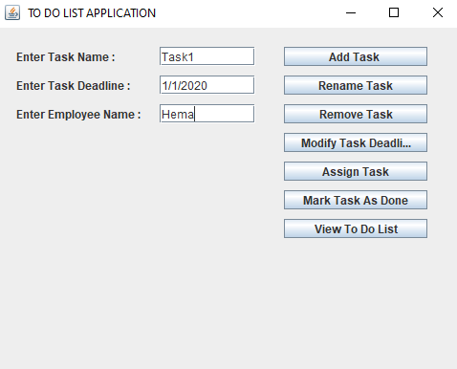

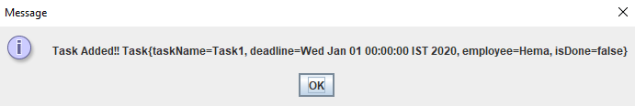

Adding Task into database

com.mysql.jdbc.JDBC4Connection@6284fa7f

Connected

Task Added Successfully



2.] Add Task

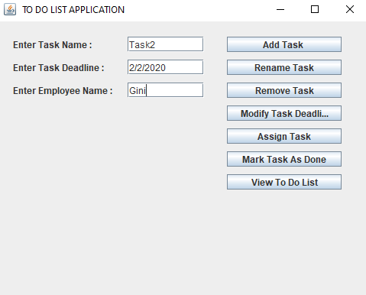

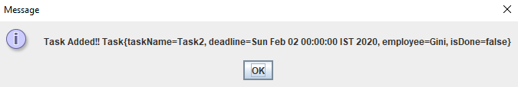

Adding Task into database

com.mysql.jdbc.JDBC4Connection@7a72d05d

Connected

Task Added Successfully

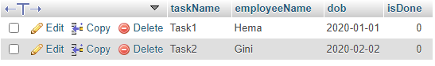

3.] Add Task

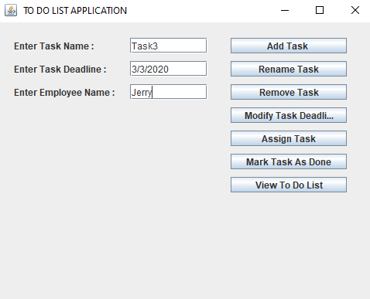

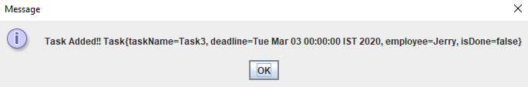

Adding Task into database

com.mysql.jdbc.JDBC4Connection@3032239e

Connected

Task Added Successfully

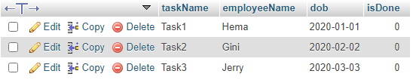

4.] Add Task

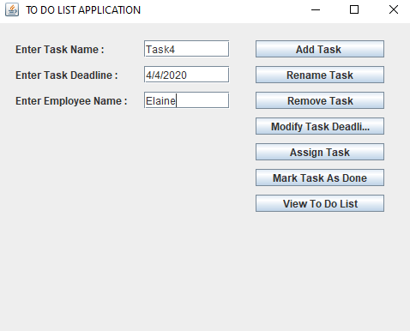

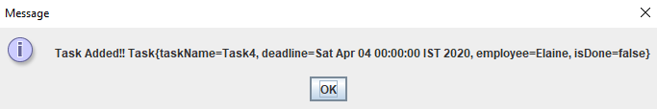

Adding Task into database

com.mysql.jdbc.JDBC4Connection@7a8c987a

Connected

Task Added Successfully

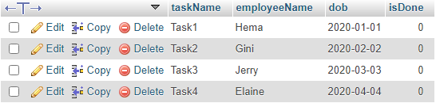

5.] Add Task

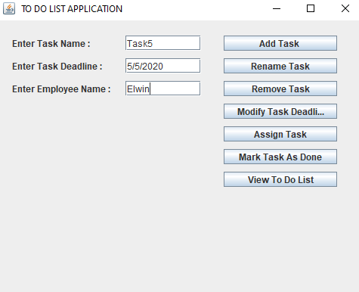

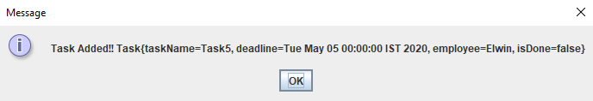

Adding Task into database

com.mysql.jdbc.JDBC4Connection@319cae4c

Connected

Task Added Successfully

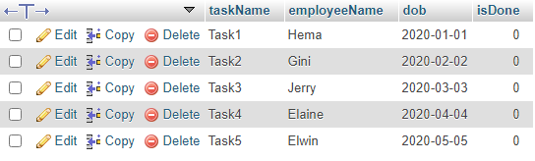

6.] Rename Task

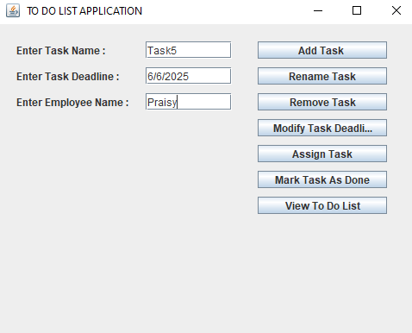

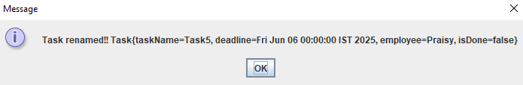

Inside rename task

com.mysql.jdbc.JDBC4Connection@4da7d410

Connected

Successfully Updated

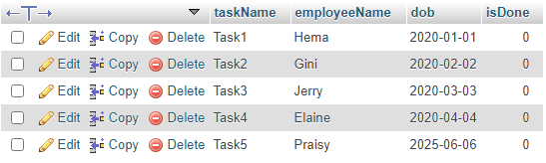

7.] Remove Task

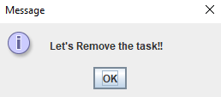

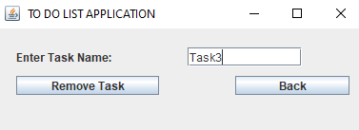

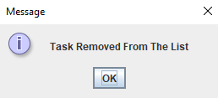

Removing Task

com.mysql.jdbc.JDBC4Connection@4e931c52

Connected

Task Deleted Successfully

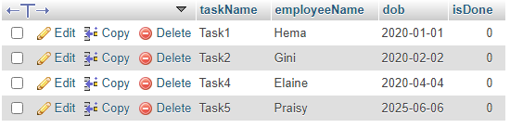

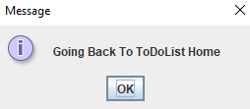

8.] Modify Task Deadline

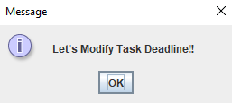

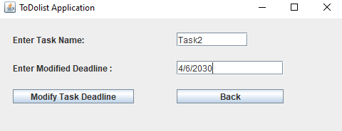

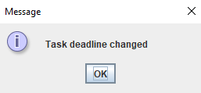

Assigning Deadline Task

com.mysql.jdbc.JDBC4Connection@4ae768bd

Connected

DeadLine Modified Successfully

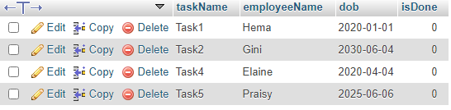



9.] Assign Task

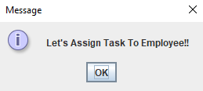

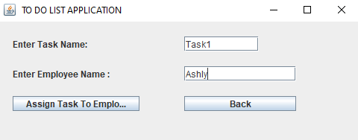

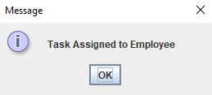

Assigning Task

com.mysql.jdbc.JDBC4Connection@8192098

Connected

Assigned Task Successfully

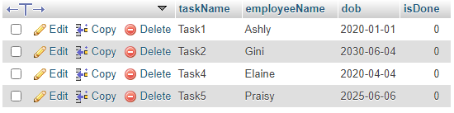



10.] Mark Task As Done

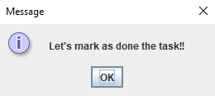

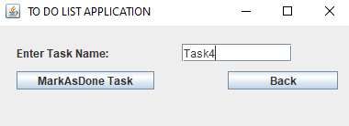

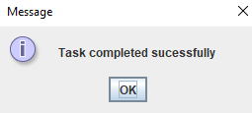

Marking as Done

com.mysql.jdbc.JDBC4Connection@10305a53

Connected

Task Marked done Successfully

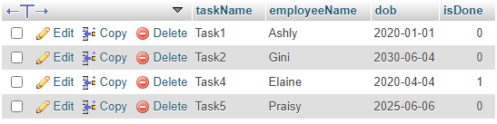



11.] View To Do List

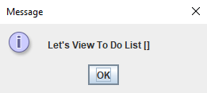

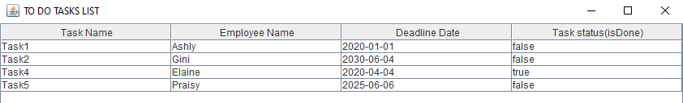

com.mysql.jdbc.JDBC4Connection@5bfc844b

Connected